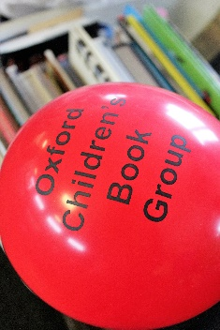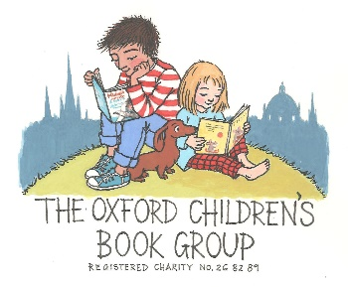
***
OCBG Biennial Conference 2019
With a brilliant line-up of authors and speakers, including Janina Ramirez, Linda Newbery, Tom Palmer, Patricia Murphy, Bill Laar…
Saturday October 12th
at Oxford University Press
9.30 am – 4 pm
OCBG/FCBG Members - £40
(£52 - including buffet lunch) Non-members welcome- £60/72
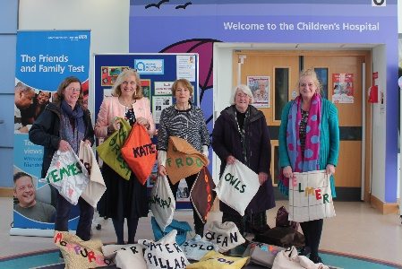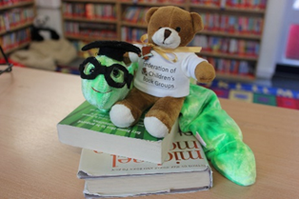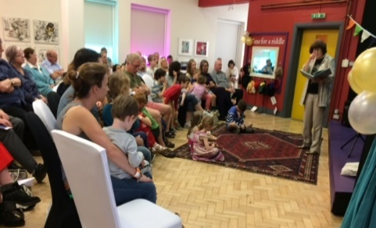
OCBG giving Story Sacks to the Children’s Hospital and our 25th birthday party at the Story Museum!
***
For more information, contact:
OCBG Chair, Jackie Holderness jh@wordscapesint.co.uk

'I really enjoyed myself at the OCBG conference as it really started me thinking on how I could include storytelling more into my lessons as a teacher. The speakers were really inspiring, and the group members were warm and welcoming.' (FCBG Member and Drama teacher, Somerset)
Feedback from the OCBG Conference in 2017
‘Once again, a wonderful and inspiring day-thank you! It is such a treat to meet the authors and to find out about so many exciting initiatives to encourage young readers.’ (Parent and School Governor, Oxfordshire)

Draft programme for the day: Oct 12th 2019

9.00-9.30 Arrival, Registration/Blackwell’s bookshop
9.30- 9.45  9.45-10.25 | Welcome and Intro: on behalf of OCBG Committee  Linda Newbery -Author of The Key to Flambards
10.30-11.00 11.00-11.40  11.45-12.25  12.30-13.30 13.30-14.00  14.00- 14.30  14.30-15.15  15.15- 15.45 | Coffee/bookshop /signing (Linda)  Tom Palmer– Author of D-Day Dog and Armistice Runner- CBA winner 2019  Janina Ramirez– Author of the Viking Mystery books  LUNCH /signing (Janina and Tom)  Oxford Heroes and Heroines: Isy Mead (Story Museum); Jackie Holderness (Christ Church Cathedral);  Patricia Murphy- Author of Leo’s War  Bill Laar- Conclusion: Learning from our childhood Heroes and Heroines  Bookshop open / Signing / Depart

PLEASE NOTE: There is parking for the disabled in the grounds of the Press. The Conference Fee is £40 for members of OCBG, and £60 for non-members. Non-members are then welcome, if they wish, to a year’s free membership which includes 3 editions of the FCBG’s Carousel magazine (worth £15).
Lunch will be provided by caterers and will cost an additional £12. Please indicate if you wish to order lunch. There is space to sit if you prefer to bring your own lunch.

All enquiries to: Jackie Holderness (Chair OCBG) on 01865-862640 or jh@wordscapesint.co.uk
All bookings to: Fay Sinai (Treasurer OCBG) 18 Mill Stream Court Abingdon OX14 5XA.

Booking form info (we will not share your details with anyone else):
Name…………………………………………………………………………………………………..
Address…………………………………….
Post Code ……………… Mobile Tel. No.………………….. Email ……………………………………

Are you a member of the FCBG or OCBG? Yes/No
If you are a member of a different local CBG group, which group? ………………………………………
If you are a Professional or Group Member, which organization or school? ..……………..…………
Individual non-members are welcome to a year’s free trial membership (worth £15) Yes /No

Full day’s Conference – Please book by 15th September 2019, if you can, but latecomers welcome!
Name(s) | OCBG or FCBG Member (individual  or group)£40 | Non member  £60 | Lunch £12 | Total

Will you require a certificate of attendance? Yes / No
Any special dietary allergies/ requirements?.....................................................
Any access difficulties? ......................................................................

To book, send this booking form and post cheques to –
Fay Sinai, 18 Mill Stream Court, Abingdon, OX14 5XA. Cheques to be made payable to OCBG.
Please write your name on the reverse of the cheque. OR… You can pay by BACS to: OCBG
Bank code: 30-96-35 Account number: 00330918. Thank you!

