February UpdaTED 2016
Dear Group Chair,

Reminders
- Book group subscriptions are now overdue. Thank you to all groups who have been so prompt this year. If you haven’t sent me your subscription by March 1st your group and your events will no longer be insured.
- March 10th is the closing date for booking your place at Conference.

Conference 2016

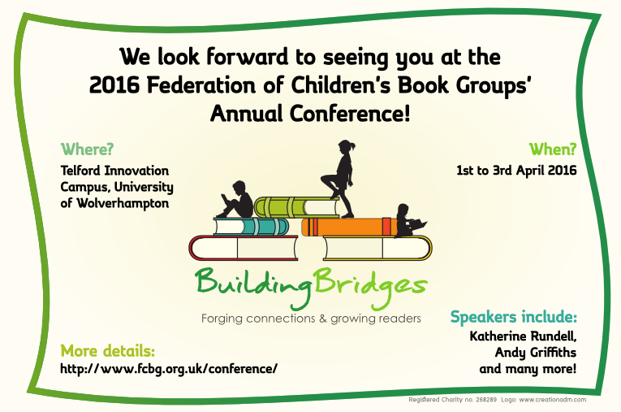

- Please let me know if your group would be keen to host future Conferences. We pride ourselves on the smooth running of our Conferences and the effective and efficient way in which book group members pull together is a major feature commented upon by delegates.

- I would also welcome any ideas/suggestions to celebrate our 50th birthday in terms of activities, venues, and displays. Contact me on info@fcbg.org.uk.

Conference Programme 2016
Final bookings : March 10th 2016 to Jane Etheridge on fcbgconference@gmail.com
Don’t forget to browse the Publishers’ Exhibition and sign up to anything on offer.

In preparation for the AGM all Book groups will receive forms to nominate a person for election to the Exec and to table a resolution for consideration at the AGM, by Friday 4th of March.
Book Group Meeting
Any items for the agenda to me on info@fcbg.org.uk by March 1st please.
Provisional Programme for FCBG Conference 2016
1st to 3rd April Telford Innovation Campus
Friday
Time | Event
4.00 – 5.15 | Opening of conference Teas and coffees with Egmont  Welcome to publishers’ exhibition
5. 15 – 5.45 | AGM
6.00 – 6:30 | Drinks with Little Tiger
6.30 – 7.45 | Dinner
7.45 – 8.30 | Katherine Rundell
8.30 | Quiz with Andersen Press in bar
Saturday
Time | Event
9 – 10.00 | Phil Earle and Curtis Jobling
10.05 – 10.50 | Harriet Reuter Hapgood and Sara Barnard chaired by Julia Bell
10.50 – 11.30 | Coffee with Macmillan and signings
11.30 – 12.15 | Andy Griffiths
12.15 – 13.00 | Horatio Clare and Mike Revell chaired by Julia Bell
13.00 – 14.00 | Signings and lunch
14.00 – 15.00 | Seminars, Joseph Coelho, Pamela Butchart, Shane Hegarty
15.00 – 15.45 | Ali Sparkes
15.45 – 16.30 | Tea with Curious Fox and signings, time for publishers and bookshop
16.30 – 17.30 | Book group meeting
19.00 | Cocktails with Jill Murphy
19:45 | Gala Dinner with Jenny Downham
Sunday
Time | Event
9 – 10.00 | Daniel Hahn, Jane Ray and S F Said in conversation with Prue Goodwin
10.05 – 10.50 | John Boyne
10.50 – 11.30 | Coffee with Nosy Crow and signings
11.30 – 12.15 | Piers Torday
12.15 – 13.00 | Anna Comonos, the Jean Russell Storyteller 2016
13.00 – 14.00 | Signings and lunch

Website review
Julia Miller is undertaking a review of the website.
Please could you look at your book group page to check the details are correct.
Please could you send any updated materials, photos, forthcoming events, competitions and activities to Julia Miller on julia.miller@talktalk.net.

FCBG groups and social media
We already encourage all our groups to make use of social media to promote your own events, publicise other events in your locality, and pass on updates from the national FCBG or other local groups.
As we continue the search for sponsorship for the Children's Book Award it will be increasingly important to show the FCBG's reach around the country. There are lots of ways you can help with this through your own social media presence.
- if you don't already operate on Twitter/Facebook/Instagram/etc now's the time to consider it
- on all outlets acknowledge your affiliation to the FCBG - for instance say you are a member in your details or include a link to the website
- follow @FCBGNews and other local group Twitter feeds
- retweet some of the @FCBGNews tweets
- "like" the FCBG Facebook page and share its posts on your own page
- let us know you have set something up so we can follow/like you.
National Share A story Month

The NSSM pack of ideas and activities for ‘A Place for Stories’ is growing and we have made great links with The National Trust, The Canals and Waterways Trust, The Forestry Commission as well as The Wildlife Trust who are all keen to involve visitors in story sharing in unusual places. This is only one aspect of our initiative but should be fun to take up! As part of this every group will be sent a copy of Chris Lloyd’s Wallbook Timeline of British History which links to 10 National Trust properties where important events have taken place.
Look out for your copy which should arrive late March and send in a review!

The NSSM pack will be with all groups by the beginning of March.

We’re looking forward to hearing about the story sharing events you have planned

We have received the following information
for events which you and your group members may find of interest.

Children’s Book Festival 2016

Celebrating 150 years of Beatrix Potter
at Wray Castle 4−6 March 2016

Come and meet your favourite authors and illustrators including Alex Schefffler, Philip Ardagh,
Benji Davies, Sophy Henn, Steve Antony, Jo Empson, Christopher Lloyd,
Malcolm Judge, Phoenix Comics, Tracey Corderoy and Steven Lenton.

Full programme and ticket booking available at www.nationaltrust.org.uk/kidsbookfest
Beatrix Potter™ © Frederick Warne & Co. 2016
FT WEEKEND OXFORD LITERARY FESTIVAL UNVEILS CHILDREN’S PROGRAMME
The Festival runs from Saturday 2nd April to Sunday 10th April in historic venues across Oxford
The FT Weekend Oxford Literary Festival has confirmed a stellar line up of internationally renowned and celebrated figures in children’s literature in this year’s Children’s and Young People’s Programme. More than 55 events have been announced for Children and Young People, including a series of free events on both weekends in the Weston Library of the Bodleian Library.
The fantastic line up of speakers at the Festival includes:
- Dame Jacqueline Wilson  - Chris Riddell  - Julian Clary  - Liz Pichon  - Lucy Worsley | - Jewell Parker Rhodes  - Frances Hardinge  - Lauren Child  - David Baddiel  - Philip Reeve
One of the highlights of the Festival, which is celebrating its 20th Anniversary this year, is former Children’s Laureate and award-winning author Dame Jacqueline Wilson who will speak about some of her most beloved characters and will give a sneak preview of her brand new book, Rent-a-Bridesmaid. This year’s Costa Book Award Winner Frances Hardinge, author of The Lie Tree, and award-winning author Philip Reeve will also discuss their celebrated books and influences on their writing.
New Children’s Laureate and creator of Alienography and the Ottoline series Chris Riddell will be speaking about his love of drawing at Meet the Laureate and drawing the answers to audience members’ questions during his talk. Comedian, novelist and television presenter David Baddiel will introduce his new children’s book The Person’s Controller whilst comedian and novelist Julian Clary and illustrator David Roberts will host a special event to introduce their new book, The Bolds to the Rescue with jokes, readings from the book and live illustrations.
Popular historian and television presenter Lucy Worsley will speak on her debut children’s novel Eliza Rose. Set in Henry VIII’s court the story follows Henry’s fifth wife Katherine Howard and her maid of honour Eliza Camperdowne. Best-selling author Liz Pichon will read from her latest Tom Gates book as well as leading fun-packed quizzes and doodle demonstrations.
As part of the Festival’s American Programme, award-winning American author Jewell Parker Rhodes will speak to writer Wendy Meddour on the topical subject of diversity in children’s books and will discuss her popular Louisiana Girls trilogy which explores themes of coming of age and adversity.
A special event taking place at this year’s Festival is The Great British Creative Challenge chaired by best-selling author Jonathon Stroud as part of his Freedom to Think campaign to inspire parents to give children time to use their imaginations and be creative. A fantastic panel of four authors including Stroud, Children’s Laureate Chris Riddell, adventure author Abi Elphinstone and author Alex Wheatle will explore why creativity is so important as well as creating models and artwork live on stage, with audience members taking a free creative pack home to invent their own creations.
To book tickets and to keep up to date with all the latest details and speaker announcements please visit the website: http://oxfordliteraryfestival.org/
Celebrate Shakespeare Week

Get ready for Shakespeare Week 14 – 20 March 2016
when primary children all around the country will be celebrating
Shakespeare’s life, world and plays. Join in the celebrations at www.shakespeareweek.org.uk
where you can register for classroom activities and other fun resources.
For bookmarks and posters featuring artwork from Marcia Williams,
please contact jo.humphreys-davies@walker.co.uk

For the best children's books, look for the bear!
http://www.walker.co.uk

World Book Day
The countdown to World Book Day 2016 is officially underway! With less than THREE weeks to go, are YOU ready for the biggest, brightest, most brilliant World Book Day yet?
World Book Day takes place on Thursday 3rd of March. How are YOU going to celebrate?
World Book Day's brilliant Bumper Book Quiz takes place on Monday 22nd of February. Don't worry if you've not signed up for the record breaking attempt, you'll be able to download the KS1, 2 and 3 quiz here from Tuesday 23rd February.
Then there's World Book Day TeenFest - the biggest and best, LIVE, online books party for teens! Taking place on the 2nd and 3rd of March from 6-8pm. Read about our live Q&As with authors, exclusive TeenFest blogs, playlists, DIY videos and much, much more here.
That's not all as our incredible Imagination Channel will also launch on Monday 22nd February. The Imagination Channel will be full of short, fun videos from the World Book Day authors and illustrators. Plus! Follow up resources from the CLPE.
And little ones will love our all-new Big Little Book Corner with four charming video books and age-related activity sheets. Enjoy them here now.
As always, the World Book Day website is full of brand new book releases for every age, competitions galore, videos, activity sheets and lots more! And we're open 24/7!
World Book Day is a registered charity dedicated to fostering a love and passion for books in the young. We rely on your help to make that dream come true and we are always immensely grateful for your support and energy.

