NSSM 2016 events!
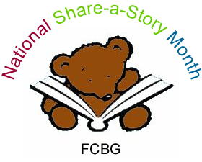

Saddleworth Children’s Book Group
The Castleshaw Quest!
We are going to a nearby reservoir at Castleshaw to complete a Quest: a family-walk where we follow a trail inspired by the landscape to save the reservoir from an evil toad! A local artist has come up with this trail and she'll be leading us.
Contact Kate Breitholtz for more information breithol@yahoo.com

South Bucks Children’s Book Group
As part of Wycombe Art Festival 2016, we are delighted to welcome the wonderfully creative, children’s author & Illustrator James Mayhew to lead our exciting storytelling and illustrating workshop: “Stories from Unusual Places” on Sat 7th May 2016
at 2 – 4pm at St John Ambulance Centre, Harlow Road. Suitable for children aged 7 years and over
Contact -Janice Saunders Tel: 01494 440849 jespaft@hotmail.com

Oxford Children’s Book Group
A storytelling event for NSSM will be held at The Painted Rooms, 3, Cornmarket, Oxford on Saturday 14th May from 10.30 to 1pm.
Contact Jackie Holderness for information jh@wordscapesint.co.uk
An Elizabethan treasure in the heart of modern Oxford
On busy Cornmarket Street, in the commercial centre of Oxford, concealed by an eighteenth-century façade, above a shop and bookmakers lies one of Oxford’s more secret historical treasures the Painted Rooms – the remains of the 14th century Crown Tavern with remarkable Elizabethan wall paintings.

The Wildlife Trusts
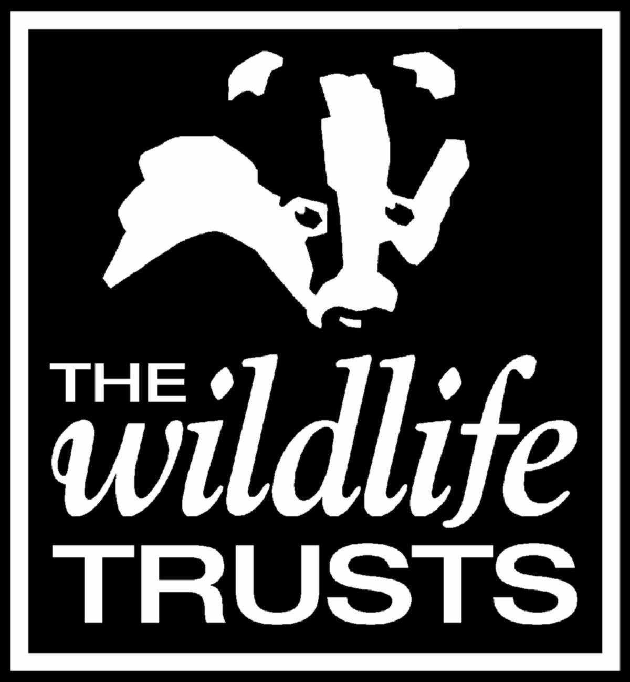
We are delighted that The Wildlife Trust are keen to promote National Share a Story Month and work with groups in sharing stories in unusual places. Visit their very useful website to find a Wildlife Trust near you and contact them if you are inspired to hold an outside story sharing event. http://www.wildlifetrusts.org/whoweare
The following Trusts are planning story sharing events and would be pleased if a book group got involved.
The Alderney Wildlife Trust
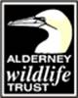
“We are planning to tell a story in an old German bunker that is now part of our community woodland. The date is the 30th May and Dr George McGavin (FLS FRGS British entomologist, author, academic, television presenter and explorer) will be reading.”
Contact Claire Thorpe peopleandwildlife@alderneywildlife.org for further information.

Avon Wildlife Trust (AWT)
“Avon Wildlife Trust (AWT) are thrilled to be launching a new project called My Wild Child – it focuses on children and families having fun outdoors in local, urban green spaces. We plan to run sessions for pre-schoolers during term-time, and wider family events during holidays. We would like to link in with NSSM in May half-term, and use storytelling as part / whole of the theme of our family holiday sessions. The same session will be run at the 6 My Wild Child sites around Bristol, which are mainly parks and one of our nature reserves. NSSM book groups may like to attend our nature reserve event, since this site is vast and affords many opportunities for exploration and discovery!”
Contact Sarah if you would like to be involved!
Sarah Horsell Sarah.Horsell@avonwildlifetrust.org.uk

Surrey Wildlife Trust
Surrey Wildlife Trust have a busy summer schedule already planned and they hope to incorporate some storytelling into some of their regular sessions. They have a storytelling event arranged for July
Contact Laura Ashfield Laura.Ashfield@surreywt.org.uk

Essex Wildlife Trust
Essex Wildlife trust are interested in organising story telling events during May. Do get in touch if you are interested in taking part.
Becky Gibson BeckyG@essexwt.org.uk

Radnorshire Wildlife Trust
“We holding an event on Bank holiday Monday 30th May which is about finding stories in our beautiful nature reserve in Mid Wales called Gilfach.”
Contact Suzie Fraser for more information. suzie@rwtwales.org
Nower Wood Educational Nature Reserve, Leatherhead, Surrey
Contact Lucy Gummer NowerWood@surreywt.org.uk for news of storytelling events during May.
Norfolk Wildlife Trust are planning an event at The Forum in Norwich at the end of May. https://www.norfolkwildlifetrust.org.uk/whats-on/all-events/2016-05-21-wild-in-the-city
Contact Annabel Hill at annabelh@norfolkwildlifetrust.org.uk
Rutland Water Nature Reserve
Contact Becky Corby about an event at Rutland Water
becky@rutlandwater.org.uk
*******************************************************************

